# ATDD Class Setup for macOS

NOTE: This guide assumes that you already have Docker installed into your Mac computer per the instructions you were provided via email.

1. Go to the GitHub repository for the virtual machine used in the class:  <https://github.com/leandog/atdd-linux-vagrant-vm>
2. Download the entire repository by cloning it locally with Git. If you don’t already have Git installed, no problem. Just download a ZIP version of the repository 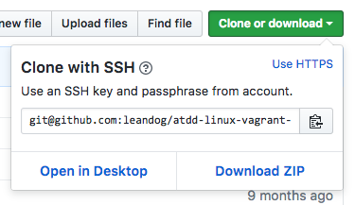
3. If you downloaded a ZIP version of the repository, use the Finder to find the file (usually in your Downloads folder) and double-click on it to decompress/unzip it.
4. Launch the Terminal app so that you can get a command prompt in macOS. 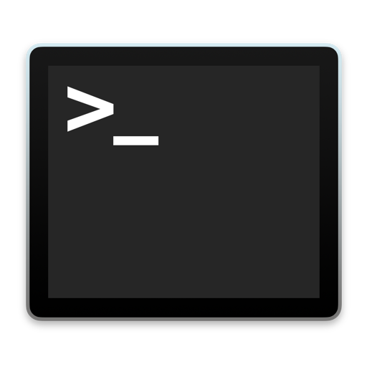
5. Use the **cd** command to navigate to the repository folder. If you don’t know the exact location of your folder, you can simply type **cd** and a space after that, then drag the folder containing the repository into Terminal. Terminal will expand the folder location into the window. Then hit Enter to switch to that directory. 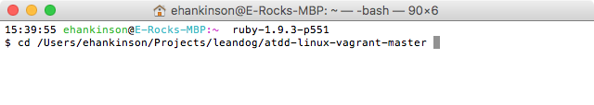
6. Now that you are in the directory, type **vagrant up** and press Enter 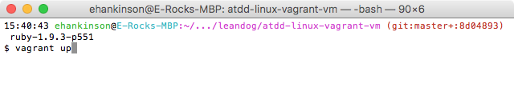
7. Now you wait for some time (roughly 5-10 minutes depending on the speed of your Internet connection).
8. Once the virtual machine is ready, you will see the desktop with the LeanDog logo.

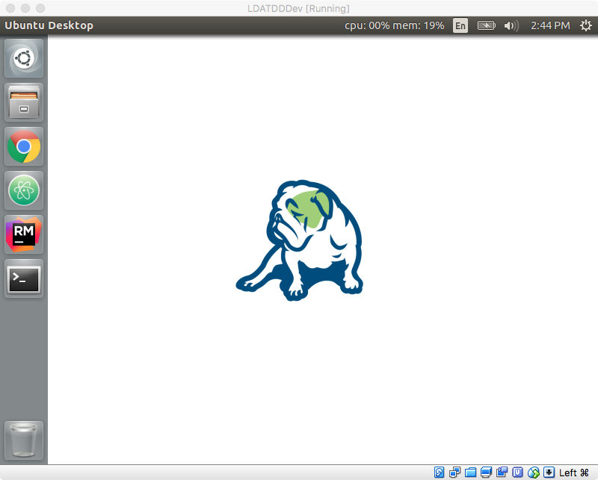

1. Celebrate! You are now ready for the class!